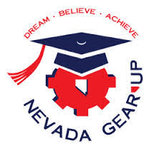

SUMMER 2018 STATEWIDE STUDENT CONFERENCES, CAMPS, CLASSES
(note all dates and venues are tentative until confirmed later this fall)

Contact the Ambassador at the institution listed next to each event for more information,
or Ambassador Coordinator Daniel Villanueva: dvillanueva@nshe.nevada.edu, 785 784 3414.

Single-Occurrence Events:

June 5 - 7: Summer Academy (UNLV/NSC/CSN, overnight)

June 18 - 24: Latino Youth Leadership Conference (CSN/UNLV, overnight)

June 25 - 27: STEM Academy (GBC, overnight)

June 28 - 29: Men's Youth Conference (NSC, no overnight)

July 23 - 25: Youth Leadership Summit (Las Vegas, overnight)

July 26 - 27: Senior Boot Camp (UNR, no overnight)

August 7 - 10: College Camp (CSN, for those admitted and attending CSN in fall 2018, no overnight)

August 8 -10: Senior Boot Camp Rural NV (UNR, overnight)

Longer-term or Multiple-date Events:

June 11 - July 6: Dual Credit Classes (TMCC, two course options, no overnight possible)

July 20, July 27, August 3, August 10, August 17, August 24: Rising Freshman Office Hours/Workshops
(UNR, for those admitted and attending UNR in fall 2018)

